**Documentation of the Database overall:**

At the moment, data on endemic Hawaiian species is being kept on spreadsheets but the Biology Department anticipates that as more information is collected the current system will hurt more than help. The database will be cataloging the different endemic Hawaiian species collected as well as when, where and by whom. The database will allow the general public across the world that is interested in endemic Hawaiian species to view information regarding where certain species are found as well as giving the biologists a way to store and research their information efficiently.

The entities/relationships that we added to the EER model were the location_details, specimen_location_code, and upload_column_names. The entity upload_column_names is used to facilitate the entry of information through the bulkload update. Upload_column_names stores the collector’s abbreviation and the name they use as a header for their xml (the format the bulkload accepts) document as primary keys with attribute_name representing the actual database attribute name and name_type specifying the taxonomy name. We needed to link a specimen to a location detail because originally the location detail was in the location table which was then linked to the event table. The problem with this is that many specimens were collected at one event and each specimen needed to be linked to their own location detail. Thus, we split off the location detail from the location table and created a relationship between specimen and location detail called specimen_location_code.

**Please find the Entity Relationship Model on Attachment 1.**

**Please find the Database Schema on Attachment 2.**

**The create script in order to generate the database:**

CREATE TABLE locality (

locality_name VARCHAR(100) NOT NULL,

PRIMARY KEY(locality_name)

);

CREATE TABLE sex (

sex_code CHAR(6) NOT NULL,

sex_type VARCHAR(255) NULL,

PRIMARY KEY(sex_code)

);

CREATE TABLE preservation_status (

status_code CHAR(4) NOT NULL,

status_description VARCHAR(255) NULL,

PRIMARY KEY(status_code)

);

CREATE TABLE organization (

abbr4_organization CHAR(4) NOT NULL,

organization_name VARCHAR(50) NOT NULL,

organization_street VARCHAR(50) NULL,

organization_city VARCHAR(50) NULL,

organization_state VARCHAR(50) NULL,

organization_zip VARCHAR(10) NULL,

organization_note VARCHAR(255) NULL,

organization_country VARCHAR(50) NULL,

PRIMARY KEY(abbr4_organization)

);

CREATE TABLE media_type (

file_format CHAR(4) NOT NULL,

media_type_note VARCHAR(255) NULL,

PRIMARY KEY(file_format)

);

CREATE TABLE meta (

meta_item CHAR(10) NOT NULL,

PRIMARY KEY(meta_item)

);

CREATE TABLE location_details (

location_detail_code INTEGER UNSIGNED NOT NULL AUTO_INCREMENT,

north_degree DECIMAL(12.7) NOT NULL,

west_degree DECIMAL(12.7) NOT NULL,

elevation_foot DECIMAL NULL,

waypoint VARCHAR(25) NULL,

utm_zone INTEGER UNSIGNED NULL,

utm_band CHAR(1) NULL,

utm_nothing INTEGER(7) UNSIGNED NULL,

utm_easting INTEGER(7) UNSIGNED NOT NULL,

PRIMARY KEY(location_detail_code)

)

TYPE=InnoDB;

CREATE TABLE reserve_permission (

permission_type CHAR(20) NOT NULL,

PRIMARY KEY(permission_type)

);

CREATE TABLE life (

short_scientific_name CHAR(9) NOT NULL,

scientific_name VARCHAR(50) NOT NULL,

PRIMARY KEY(short_scientific_name),

FULLTEXT INDEX life_FullText1(scientific_name),

UNIQUE INDEX life_Unique1(scientific_name)

);

CREATE TABLE taxonomy (

rank_name CHAR(15) NOT NULL,

rank_name_2 CHAR(15) NOT NULL,

mandatory ENUM('yes','no') NOT NULL,

PRIMARY KEY(rank_name),

INDEX taxonomy_FKIndex1(rank_name_2),

FOREIGN KEY(rank_name_2)

REFERENCES taxonomy(rank_name)

ON DELETE NO ACTION

ON UPDATE NO ACTION

);

CREATE TABLE rank_type (

rank_type CHAR(25) NOT NULL,

PRIMARY KEY(rank_type),

FULLTEXT INDEX rank_type_FullText1(rank_type)

);

CREATE TABLE island (

island_name CHAR(10) NOT NULL,

PRIMARY KEY(island_name)

);

CREATE TABLE container (

cabinet_code CHAR(5) NOT NULL,

box_code CHAR(9) NOT NULL,

section_code CHAR(9) NOT NULL,

abbr4_organization CHAR(4) NOT NULL,

PRIMARY KEY(cabinet_code, box_code, section_code, abbr4_organization),

INDEX container_FKIndex1(abbr4_organization),

FOREIGN KEY(abbr4_organization)

REFERENCES organization(abbr4_organization)

ON DELETE NO ACTION

ON UPDATE NO ACTION

);

CREATE TABLE collector (

abbr3_collector CHAR(3) NOT NULL,

first_name VARCHAR(50) NOT NULL,

last_name VARCHAR(50) NOT NULL,

middle_name VARCHAR(50) NULL,

email VARCHAR(50) NOT NULL,

passwd TEXT NULL,

abbr4_organization CHAR(4) NULL,

user_name VARCHAR(8) NULL,

PRIMARY KEY(abbr3_collector),

INDEX collector_FKIndex1(abbr4_organization),

FOREIGN KEY(abbr4_organization)

REFERENCES organization(abbr4_organization)

ON DELETE NO ACTION

ON UPDATE NO ACTION

);

CREATE TABLE upload_column_names (

abbr3_collector CHAR(3) NOT NULL AUTO_INCREMENT,

xml_name VARCHAR NOT NULL,

attribute_name VARCHAR NULL,

name_type ENUM('taxon','column') NULL,

PRIMARY KEY(abbr3_collector, xml_name),

INDEX upload_column_names_FKIndex1(abbr3_collector),

FOREIGN KEY(abbr3_collector)

REFERENCES collector(abbr3_collector)

ON DELETE NO ACTION

ON UPDATE NO ACTION

)

TYPE=InnoDB;

CREATE TABLE reserve (

reserve_name CHAR(20) NOT NULL,

permission_type CHAR(20) NULL,

PRIMARY KEY(reserve_name),

INDEX reserve_FKIndex1(permission_type),

FOREIGN KEY(permission_type)

REFERENCES reserve_permission(permission_type)

ON DELETE NO ACTION

ON UPDATE NO ACTION

);

CREATE TABLE dna (

extraction_code CHAR(9) NOT NULL,

section_code CHAR(9) NOT NULL,

box_code CHAR(9) NOT NULL,

cabinet_code CHAR(5) NOT NULL,

abbr4_organization CHAR(4) NOT NULL,

sequence TEXT NOT NULL,

sequence_name VARCHAR(50) NOT NULL,

primer_name VARCHAR(50) NOT NULL,

PRIMARY KEY(extraction_code),

FULLTEXT INDEX dna_FullText1(sequence),

INDEX dna_FKIndex1(abbr4_organization, cabinet_code, box_code, section_code),

FOREIGN KEY(abbr4_organization, cabinet_code, box_code, section_code)

REFERENCES container(abbr4_organization, cabinet_code, box_code, section_code)

ON DELETE NO ACTION

ON UPDATE NO ACTION

);

CREATE TABLE media (

media_id INTEGER UNSIGNED NOT NULL AUTO_INCREMENT,

file_format CHAR(4) NOT NULL,

directory_path VARCHAR(125) NOT NULL,

file_name VARCHAR(125) NOT NULL,

media_note VARCHAR(255) NULL,

PRIMARY KEY(media_id),

INDEX media_FKIndex1(file_format),

INDEX media_Unique1(directory_path, file_name, file_format),

FOREIGN KEY(file_format)

REFERENCES media_type(file_format)

ON DELETE NO ACTION

ON UPDATE NO ACTION

);

CREATE TABLE taxonomy_rank (

rank_name CHAR(15) NOT NULL,

rank_type CHAR(25) NOT NULL,

PRIMARY KEY(rank_name, rank_type),

INDEX taxonomy_rank_FKIndex1(rank_type),

INDEX taxonomy_rank_FKIndex2(rank_name),

FOREIGN KEY(rank_name)

REFERENCES taxonomy(rank_name)

ON DELETE NO ACTION

ON UPDATE NO ACTION,

FOREIGN KEY(rank_type)

REFERENCES rank_type(rank_type)

ON DELETE NO ACTION

ON UPDATE NO ACTION

);

CREATE TABLE dna_media (

extraction_code CHAR(9) NOT NULL,

media_id INTEGER UNSIGNED NOT NULL,

PRIMARY KEY(extraction_code, media_id),

INDEX dna_media_FKIndex1(extraction_code),

INDEX dna_media_FKIndex2(media_id),

FOREIGN KEY(extraction_code)

REFERENCES dna(extraction_code)

ON DELETE NO ACTION

ON UPDATE NO ACTION,

FOREIGN KEY(media_id)

REFERENCES media(media_id)

ON DELETE NO ACTION

ON UPDATE NO ACTION

);

CREATE TABLE life_media (

short_scientific_name CHAR(9) NOT NULL,

media_id INTEGER UNSIGNED NOT NULL,

PRIMARY KEY(short_scientific_name, media_id),

INDEX life_media_FKIndex1(short_scientific_name),

INDEX life_media_FKIndex2(media_id),

FOREIGN KEY(short_scientific_name)

REFERENCES life(short_scientific_name)

ON DELETE NO ACTION

ON UPDATE NO ACTION,

FOREIGN KEY(media_id)

REFERENCES media(media_id)

ON DELETE NO ACTION

ON UPDATE NO ACTION

);

CREATE TABLE media_meta (

meta_item CHAR(10) NOT NULL,

media_id INTEGER UNSIGNED NOT NULL,

meta_numeric_value INTEGER UNSIGNED NOT NULL,

PRIMARY KEY(meta_item, media_id),

INDEX media_meta_FKIndex1(meta_item),

INDEX media_meta_FKIndex2(media_id),

FOREIGN KEY(media_id)

REFERENCES media(media_id)

ON DELETE NO ACTION

ON UPDATE NO ACTION,

FOREIGN KEY(meta_item)

REFERENCES meta(meta_item)

ON DELETE NO ACTION

ON UPDATE NO ACTION

);

CREATE TABLE life_taxonomy (

rank_type CHAR(25) NOT NULL,

rank_name CHAR(15) NOT NULL,

short_scientific_name CHAR(9) NOT NULL,

PRIMARY KEY(rank_type, rank_name, short_scientific_name),

INDEX life_taxonomy_FKIndex2(rank_type, rank_name),

INDEX life_taxonomy_FKIndex1(short_scientific_name),

FOREIGN KEY(rank_type, rank_name)

REFERENCES taxonomy_rank(rank_type, rank_name)

ON DELETE NO ACTION

ON UPDATE NO ACTION,

FOREIGN KEY(short_scientific_name)

REFERENCES life(short_scientific_name)

ON DELETE NO ACTION

ON UPDATE NO ACTION

);

CREATE TABLE location (

island_name CHAR(10) NOT NULL,

reserve_name CHAR(20) NOT NULL,

locality_name VARCHAR(100) NOT NULL,

location_detail_code INTEGER UNSIGNED NOT NULL,

PRIMARY KEY(island_name, reserve_name, locality_name),

*INDEX Location_FKIndex1(island_name),*

*INDEX Location_FKIndex2(reserve_name),*

*INDEX Location_FKIndex3(*locality_name),

INDEX Location_FKIndex4(location_detail_code),

FOREIGN KEY(island_name)

REFERENCES island(island_name)

ON DELETE NO ACTION

ON UPDATE NO ACTION,

FOREIGN KEY(reserve_name)

REFERENCES reserve(reserve_name)

ON DELETE NO ACTION

ON UPDATE NO ACTION,

FOREIGN KEY(locality_name)

REFERENCES locality(locality_name)

ON DELETE NO ACTION

ON UPDATE NO ACTION,

FOREIGN KEY(location_detail_code)

REFERENCES location_details(location_detail_code)

ON DELETE NO ACTION

ON UPDATE NO ACTION

);

CREATE TABLE event (

event_code CHAR(9) NOT NULL,

abbr3_collector CHAR(3) NOT NULL,

locality_name VARCHAR(100) NOT NULL,

reserve_name CHAR(20) NOT NULL,

island_name CHAR(10) NOT NULL,

date DATE NOT NULL,

event_note TEXT NULL,

PRIMARY KEY(event_code),

INDEX event_FKIndex1(island_name, reserve_name, locality_name),

INDEX event_FKIndex2(abbr3_collector),

FOREIGN KEY(island_name, reserve_name, locality_name)

REFERENCES location(island_name, reserve_name, locality_name)

ON DELETE NO ACTION

ON UPDATE NO ACTION,

FOREIGN KEY(abbr3_collector)

REFERENCES collector(abbr3_collector)

ON DELETE NO ACTION

ON UPDATE NO ACTION

);

CREATE TABLE event_collector (

event_code CHAR(9) NOT NULL,

abbr3_collector CHAR(3) NOT NULL,

PRIMARY KEY(event_code, abbr3_collector),

INDEX event_collector_FKIndex1(event_code),

INDEX event_collector_FKIndex2(abbr3_collector),

FOREIGN KEY(event_code)

REFERENCES event(event_code)

ON DELETE NO ACTION

ON UPDATE NO ACTION,

FOREIGN KEY(abbr3_collector)

REFERENCES collector(abbr3_collector)

ON DELETE NO ACTION

ON UPDATE NO ACTION

);

CREATE TABLE collection (

catalog_code CHAR(9) NOT NULL,

event_code CHAR(9) NOT NULL,

short_scientific_name CHAR(9) NOT NULL,

number_sample INTEGER UNSIGNED NULL,

number_male INTEGER UNSIGNED NULL,

number_female INTEGER UNSIGNED NULL,

collection_note TEXT NULL,

PRIMARY KEY(catalog_code, event_code),

INDEX specimen_FKIndex1(event_code),

INDEX collection_FKIndex3(short_scientific_name),

FOREIGN KEY(event_code)

REFERENCES event(event_code)

ON DELETE NO ACTION

ON UPDATE NO ACTION,

FOREIGN KEY(short_scientific_name)

REFERENCES life(short_scientific_name)

ON DELETE NO ACTION

ON UPDATE NO ACTION

);

CREATE TABLE specimen (

specimen_code CHAR(12) NOT NULL,

event_code CHAR(9) NOT NULL,

catalog_code CHAR(9) NOT NULL,

cabinet_code CHAR(5) NOT NULL,

box_code CHAR(9) NOT NULL,

section_code CHAR(9) NOT NULL,

abbr4_organization CHAR(4) NOT NULL,

sex_code CHAR(6) NULL,

status_code CHAR(4) NULL,

PRIMARY KEY(specimen_code),

INDEX specimen_FKIndex1(abbr4_organization, cabinet_code, box_code, section_code),

INDEX specimen_FKIndex2(status_code),

INDEX specimen_FKIndex3(sex_code),

INDEX specimen_FKIndex4(catalog_code, event_code),

FOREIGN KEY(abbr4_organization, cabinet_code, box_code, section_code)

REFERENCES container(abbr4_organization, cabinet_code, box_code, section_code)

ON DELETE NO ACTION

ON UPDATE NO ACTION,

FOREIGN KEY(status_code)

REFERENCES preservation_status(status_code)

ON DELETE NO ACTION

ON UPDATE NO ACTION,

FOREIGN KEY(sex_code)

REFERENCES sex(sex_code)

ON DELETE NO ACTION

ON UPDATE NO ACTION,

FOREIGN KEY(catalog_code, event_code)

REFERENCES collection(catalog_code, event_code)

ON DELETE NO ACTION

ON UPDATE NO ACTION

);

CREATE TABLE specimen_media (

media_id INTEGER UNSIGNED NOT NULL,

specimen_code CHAR(12) NOT NULL,

PRIMARY KEY(media_id, specimen_code),

INDEX specimen_media_FKIndex1(specimen_code),

INDEX specimen_media_FKIndex2(media_id),

FOREIGN KEY(specimen_code)

REFERENCES specimen(specimen_code)

ON DELETE NO ACTION

ON UPDATE NO ACTION,

FOREIGN KEY(media_id)

REFERENCES media(media_id)

ON DELETE NO ACTION

ON UPDATE NO ACTION

);

CREATE TABLE specimen_dna (

extraction_code CHAR(9) NOT NULL,

specimen_code CHAR(12) NOT NULL,

PRIMARY KEY(extraction_code, specimen_code),

INDEX specimen_dna_FKIndex1(specimen_code),

INDEX specimen_dna_FKIndex2(extraction_code),

FOREIGN KEY(specimen_code)

REFERENCES specimen(specimen_code)

ON DELETE NO ACTION

ON UPDATE NO ACTION,

FOREIGN KEY(extraction_code)

REFERENCES dna(extraction_code)

ON DELETE NO ACTION

ON UPDATE NO ACTION

);

CREATE TABLE specimen_location_code (

specimen_code CHAR(12) NOT NULL,

location_detail_code INTEGER UNSIGNED NOT NULL,

PRIMARY KEY(specimen_code),

INDEX specimen_location_code_FKIndex1(specimen_code),

INDEX specimen_location_code_FKIndex2(location_detail_code),

FOREIGN KEY(specimen_code)

REFERENCES specimen(specimen_code)

ON DELETE NO ACTION

ON UPDATE NO ACTION,

FOREIGN KEY(location_detail_code)

REFERENCES location_details(location_detail_code)

ON DELETE NO ACTION

ON UPDATE NO ACTION

)

TYPE=InnoDB;

**Normalization:**

We have evaluated our database and have found that our tables are in Third Normal Form. This implies that everything in the tables are dependent on their respective primary keys and only their primary keys. Also, the attributes of the tables are dependent on the whole primary key. We did not normalize the tables any further in order to preserve the working database model of the Biology Department’s data.

**Data Dictionary part a:**

upload_column_names:

Stores the collector’s abbreviation and the name they use as a header for their xml (the format the bulkload accepts) document as primary keys with attribute_name representing the actual database attribute name and name_type specifying the taxonomy name.

location_detail:

Stores the specific coordinates of locations of where specimens have been collected.

specimen_location_code :

Stores the link from each specimen to a specific location_detail which is where they were collected.

**Please find Data Definition part b in Attachment 3.**

The SQL query used to generate Data Definition part b is as follows:

SELECT TABLE_NAME, COLUMN_NAME, DATA_TYPE FROM information_schema.COLUMNS where TABLE_SCHEMA = 'TCBES';

**Queries: (Please find the results attached in Attachment 4)**

**Query 1:** SELECT xml_name, attribute_name, name_type

FROM upload_column_names

WHERE abbr3_collector = "$_SESSION['uid'] ";

This query allows us to pull down information for the current user as to how their known naming scheme of columns corresponds to the database attributes. Query gives no results as upload_column_names is currently empty.

**Query 2:** SELECT box_code, section_code, cabinet_code, catalog_code

FROM specimen

WHERE specimen_code = ‘8’;

Finds where specimen 8 is being stored.

**Query 3:** select REFERENCED_TABLE_NAME, REFERENCED_COLUMN_NAME

from information_schema.KEY_COLUMN_USAGE

where TABLE_NAME = '%s' and COLUMN_NAME = '%s' and REFERENCED_TABLE_NAME is not null;

Used to query the information_schema to find dependancies. Results assume that TABLE_NAME = ‘specimen’ and COLUMN_NAME = ‘event_code’.

**Query 4:** select ‘yes’ as collection

from collection

where catalog_code = %s and event_code = %s

This query checks to see if there is something in the collection table that has a certain catalog code and event code combination. If there is the query returns yes otherwise it will be blank. This query is used to peruse the database for existing data with the same key values. Results assume that catalog_code = 01 and event_code = m0001.

**Query 5:** select collection.event_code, collection.catalog_code, collector.first_name,

collector.last_name, collector.middle_name, collector.abbr3_collector, life.scientific_name, life.scientific_name, event.island_name, event.reserve_name, event.locality_name, event.date,

round (location_details.north_degree,4) as north_degree, round(location_details.west_degree,4) as west_degree,

specimen.cabinet_code, specimen.box_code, specimen.section_code,

specimen.abbr4_organization

from collection, event, location, collector, life, specimen, location_details

where collection.event_code = event.event_code and

location.location_detail_code = location_details.location_detail_code and

event.island_name = location.island_name and

event.reserve_name = location.reserve_name and

event.locality_name = location.locality_name and

event.abbr3_collector = collector.abbr3_collector and

collection.short_scientific_name = life.short_scientific_name and

collection.event_code = specimen.event_code and

collection.catalog_code = specimen.catalog_code

order by collection.event_code;

**Query 6:** INSERT INTO specimen(specimen_code,event_code, catalog_code, cabinet_code, box_code, section_code, abbr4_organization, sex_code, status_code)

VALUES (%s,%s,%s,%s,%s,%s,%s,%s,%s);

Inserts into specimen a new tuple defined by the variables (used in bulkload). Results assume the tuple is (‘8’, ‘m0300’, ‘02’, ‘01’,’16’, ‘2’, ‘UHH’, ‘f’, NULL). The results state that foreign key constraints stop the update.

**Query 7:** SELECT specimen_code, north_degree, west_degree

FROM specimen_location_code, location_details

WHERE specimen_code = 1 AND specimen_location_code.location_detail_code = location_details.location_detail_code;

Finds out the north degree and west degree of specimen 1.

The results return 0 results due to specimen_location_code being empty.

**Query 8:** SELECT first_name, last_name, organization_name

FROM collector, organization

WHERE collector.abbr4_organization = organization. abbr4_organization

ORDER BY organization_name;

Lists the first and last name of every collector as well as their corresponding organization ordered by organization name.

**Query 9:** SELECT first_name, last_name, event_code

FROM event, collector

WHERE date = “2009-05-20” AND event.abbr3_collector = collector. abbr3_collector;

Lists the first and last name of every collector and event code present at any event on 5/20/2009.

**Query 10:** SELECT specimen_code, sex_type

FROM specimen, sex

WHERE sex.sex_code = specimen. sex_code;

Lists all the specimen’s specimen codes and their respective sex types.

**Query 11:** SELECT specimen_code, sequence

FROM specimen_dna, dna

WHERE specimen_dna.extraction_code = dna. extraction_code;

Lists all the specimen’s specimen codes and their respective dna sequences.

This returns no results since specimen_dna and dna are empty.

**Query 12:** SELECT first_name, last_name

FROM collector

WHERE abbr4_organization = ‘UHH’;

Lists the first name and last name of all the collector’s from the organization UHH.

**Query 13:** DESCRIBE $variable

Assuming $variable is the name of a table this query is used to describe a table in order to determine what elements also need to be added when we insert data.

Results supposing $variable = event.

**Query 14:** SELECT extraction_code

FROM dna, specimen

WHERE dna.section_code = specimen.section_code and specimen_code = ‘8’;

The result is the extraction code for all dna that share a section_code with specimen 8. The result returns 0 rows.

**Indexing:**

CREATE INDEX longitude ON location_details (north_degree);

CREATE INDEX latitude ON location_details (west_degree);

This is because when most people would like to search the location_details table they will refer to the north_degree and west_degree.

**Forms**:

We have a form that the user will submit their file to be uploaded and another form to check whether or not we missed any matching columns respectively. 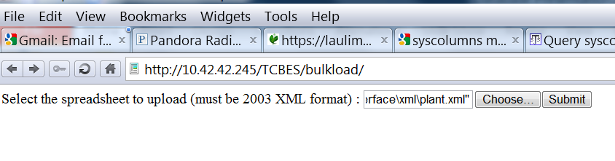

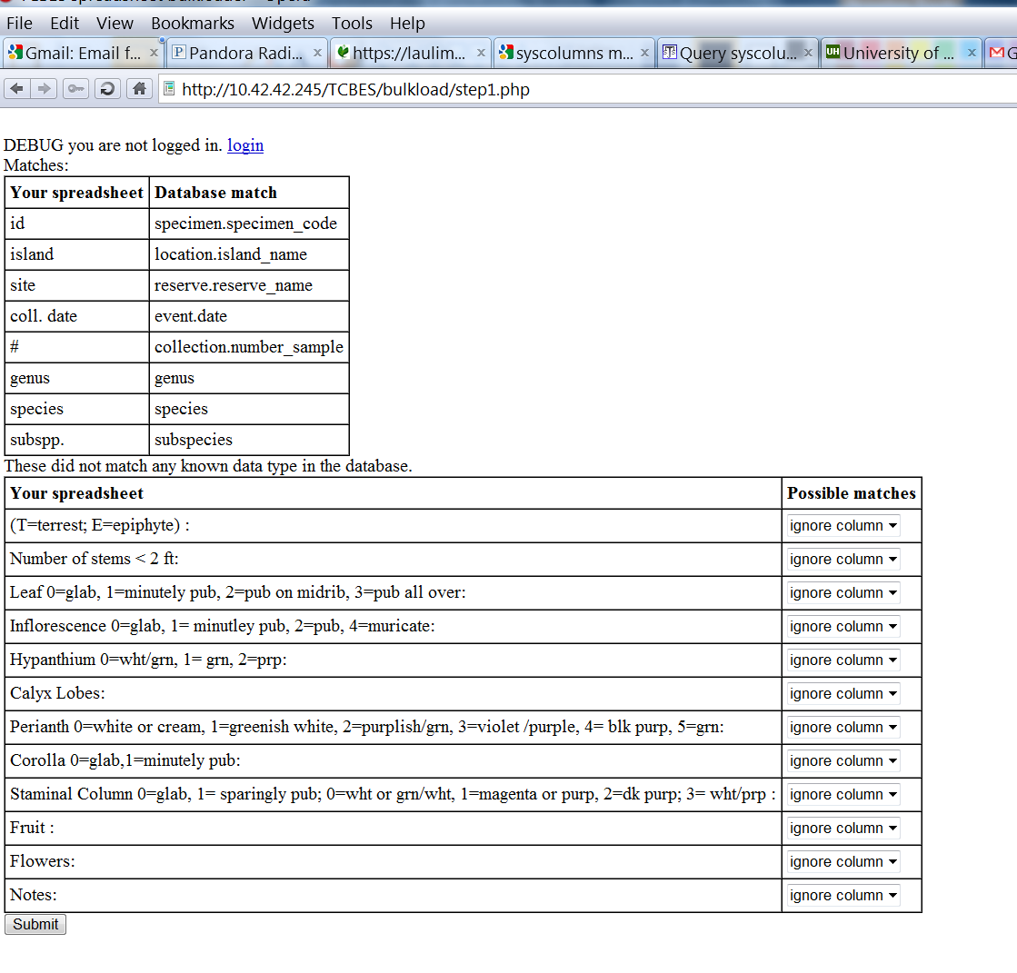

**Reports**:

We have a report that shows the user what columns in their xml file matched the database and another in _readDev.php that reports information on different events and the specimens collected respectively. 

